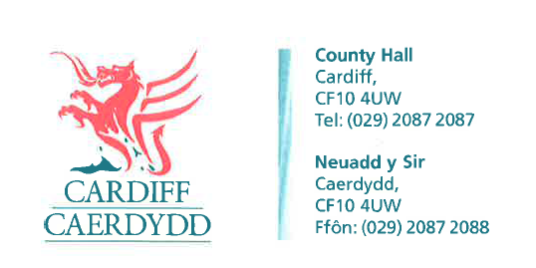
FOI Response Document
FOI09943

Thank you for your request under the Freedom of Information Act 2000 about Compulsory Purchase Orders received on 4th April 2017.
The information requested relates to the Shared Regulatory Service (SRS) which is a service provided by the Vale of Glamorgan Council on behalf of the City of Cardiff and Bridgend Councils.
Request
Please provide a list of all properties which your Council has obtained a Compulsory Purchase Order on since 1st April 2010. Please include the following information in each case:
- Property address (including postcode)
- Date which the order was obtained
The preferred format in which to receive this information is in an Excel spreadsheet

We have considered your request and enclose the following information:
Section 17 of the Housing Act 1985 gives Local Authorities the power to acquire buildings and land through compulsory purchase. Please see FOI 09943 attachment 1 of 1 which is a spreadsheet containing details of those properties where a Complulssory Purchase Orders was made.
Unfortunately we do not have electronic records which makes this clear, details have been take from hand written notes. All officers involved in these properties have since left the Council; whilst this function has been transferred to another officer there have not been any further CPO’s issued.
Please note that this request is being processed by City of Cardiff Council on behalf of the Shared Regulatory Service (SRS).
If you have any queries or concerns, please do not hesitate to contact us.
Please remember to quote the reference number above in any future communications.

